1
10TH INTERNATIONAL SYMPOSIUM ON "SOLUBILITY PHENOMENA APPLICATION FOR ENVIRONMENTAL

IMPROVEMENT"

21ST -24TH JULY, 2002
HOME OF SCIENTIST F.J.CURIE -VARNA
POSTER SESSION - P 28

THE BULGARIAN CLINOPTILOLITE ZEOLITITE - AS A MINERAL NUTRITION SUPLEMENT

N. Izmirova (a), B. Aleksiev (b), E. Djourova (b), M. Baeva (c), A. Boyanova (c), D. Pressiyanov (d), L. Minev (d), T. Boshkova (d), P. Uzunov (d), P. Blagoeva (e), Z. Gendgev (e), Tz. Mircheva (e), I. Tomova (f), R. Bozhikova (g)

(a) Sofia University, Faculty of Chemistry; (b) Sofia University, Faculty of Geology and Geography; (c) BAS Institute of Solid State Physics; (d) Sofia University, Faculty of Physics; (e) National Oncological Center, (f) Sofia Sanitary Inspection (g) "Pirogov" First Aid Hospital, Sofia, Bulgaria

Introduction

In Bulgaria there are enormous amounts of different zeolite minerals that have industrial value. They were found by B.Aleksiev (1968), investigated and proposed for wide-spectrum application by B.Aleksiev [1] and E.Djourova [2].
According to Marinov [3] the exclusively high absorption capacity of the natural Clinoptilolite (Cpt) powder towards artificial radionuclides ¹³⁷Cs and ⁹⁰Sr makes it applicable in practice, as additive in the prophylactic nutrition for purification of waters, for desactivation of substances with low or middle activity.
During 1986 Chernobyl disaster the Bulgarian Government did not pay any attention to recommendations [4], [5], [6] for radiation protection at radioactive pollution. Elementary measures were not taken for the prevention of the nation from the radioactive contamination. [4]
This fact is known by everyone in Bulgaria. It is strange that Filizova [7] reports that the Bulgarian children were given biscuits, chocolates and pastries containing 2-30 wt.% Clinoptilolite for prevention of radioactive contamination during 1986. The Filizova's assertion in [7] is not true.
In the same time a thesis [8 St.Nikolova,1986] is defenced in which the Bulgarian Cpt. is declared as a powder with biological aggressivity. In conclusion No 5, pp. 132-133 it is written: "The Cytotoxic action is weakly developed at Erionite, middle at Mordenite and strongly expressed at Clinoptilolite. At the three type zeolite powders it was observed experimental carcinogenic activity." Moreover, the above statements persist in papers [9,10].
That is the main reason why we started at the beginning of 1998 investigation for carcinogenesis of the natural Clinoptilolite zeolitite (Cpt.z) on mice and rats. It was deduced (P.Blagoeva et al.2001) [11] that the Bulgarian Cpt.z from NE Rhodopes has no general toxic effect upon liver, lung, heart, spleen and kidneys. Cpt.z has no clastogenic effect upon the mice bone marrow. Cpt.z has no carcinogenic effect on laboratory animals - mice and rats [11]. The investigations of P. Blagoeva [11,13] deny the assertion that Bulgarian Cpt.z possess carcinogenic activity [8].
In experiments carried out on mice, we observed that exist a certain tendency toward reduction of tumor formations in those of them treated with Cpt.z when compared to those not treated with it, especially in regards the Lymphomas - Lymphosarcoma, and Reticulum-cell neoplasm type B [12,13].
The Bulgarian natural Cpt.z is especially appropriate to be applied as food supplement for the maintenance of the acid-balance, osmotic pressure, electro lite and mineral balance in the human body [14-17].
Element composition of Cpt.z (in mg per 1000 g) [18]:
Pb-36-56 Cr-< 0,5-1,75 Li-0,4-0,5
Mn-55 Ni-< 0.5-0,75 As-0,72
Zn-45 Co-< 0,5-0,75 Cd-0,18
The element relations between K, Ca, and Mg quantities are similar of these in the human blood.
The natural radioactivity of Cpt.z was studied by means of gamma-ray spectrometry analysis. The measurements were carried out on gamma-ray spectrometry system including a ORTEG HPGe detector (relative efficiency 24.9 % and resolution 1.9 keV for Co-60 1332 keV line).
The natural radioactivity of Cpt.z (in Bq/kg) in the deposit regions is as follows:
²³⁸U – 50-185; ²²⁶Ra – 60-200; ²³²Th –120-170; ⁴⁰K – 750-1300. Despite of this natural radioactivity the content of ²²⁶Ra in drinking water percolating through Cpt rocks is lower than Minimal Detectable Activity (MDA) 0,07 Bq/1 (the maximum permissible concentration is 0,15 Bq/1). The Rn emanation in Cpt-built houses after 6-month stay of track detectors was not proved. Despite of the natural radioactivity of Cpt.z an increase of neoplasm diseases among the native population of these regions was not observed [18].
The extraction of Cpt.z. with 0.3 N HCI (acidity comparable with this of stomach contained) is carried out during 2 hours at temperature 45⁰ C and continuous mixturing. The level in the HCl-extract of the Uranium - 238 (<10), Radium - 226 (<3), Torium - 232 (<7) does not exceed MDA. This confirms that the radionuclides U-238, Ra-226 and Th-232 are very hard connected to the aluminosilicate skeleton of the Cpt.z [19].
The Cpt.z. was received by grounding of natural Cpt.z. to the size of particles until a granulometric composition was received:
- particles with size, smaller than 0.01 mm.- 70.2 %
- particles with size from 0.05 to 0.01 mm.- 28.6%
- particles with size from 0.10 to 0.05 mm.- 1.2 %

The result of X-ray diffraction of Cpt.z is given on Grafic 1. It is seen that in the Cpt.z (with Clinoptilolite up to 85-90%) are found small amounts of inactive Crystobalite and Feldspare, as well as Montmorillonite. For the purpose of investigation Cpt.z in powdwr form was used instead of Cpt. because Crystoballite and Feldspare are inactive while Montmorillonite with its ion exchange, absorbtive etc. properties, will,help and even enhance the healing effect of Cpt.z

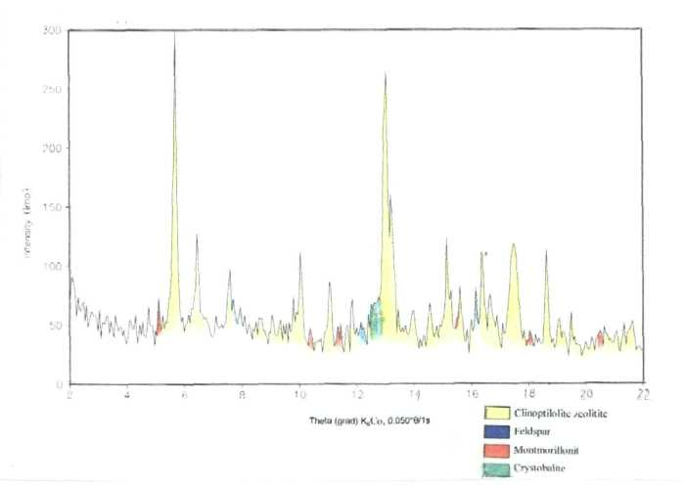

Grafic 1. X-ray diffraction pattern of Clinoptilolite zeolitite

Further research and experiments showed that Cpt.z may be applied and administered for the decrease and relief of acidity and pains in the stomach, as well as similar ailments in
the abdominal area, including nutritive, alcoholic, and exo- and endo-genous intoxications [13].
Cpt.z may also be applied and administered in cases of enhanced cancer danger, or in
cases of natural inclination toward cancerous formations in the human body. [12]
Cpt.z may be taken prophylacticaly or when in need, twice daily in doses of
2,5 to 5,0 g before breakfast in the morning and before going to bed in the evening.
For patients with increased tumour markers, Cpt.z may be applied together with the
saturation of the organism with Vit.C in a prescribed manner [17].

Use of Cpt.z as food supplement [14].
The healthy effect of Cpt.z as food supplement is determined by its properties of effective molecular sieve for purification of ammonium ion (NH₄⁺ is very toxic to the central nervous system) and other nonprotein nitrogen containing compounds. As an ion-exchanger it serves for maintaining the osmotic pressure,regulation of acid-base equilibrium, electrolytic and mineral balance in the organism.
Besides, by consuming foods in the content of which is included Cpt.z the water exchange in the organism and the drinking of liquids is stimulated. Because of its ion-exchange activity and adsorption ability, when added to food Cpt.z creates very pleasant taste sensation, which strips up additionally, typical only for it stimulation of the taste receptors.

Application of Cptz. for preparation of tooth paste, cleaning chewing gums, lotion of mouth cavity, and powders for tooth cleaning and cleaning of artificial dentures [15].
The hardness of the mineral Clinoptilolite is between 3.5 and 4 (according to Moos scale) and it has cleaning effect without abrasive such and doesn't effect the enamel surface of the teeth, which is harder than Cpt.z. (6-7 after Moos scale). This cleaning effect leads to preservation of the natural gloss of the enamel.
Cpt.z. helps in the cleaning of the tartar, by turning it into soluble suspended form, which could be easily removed, when cleaning the teeth.
Products of biocrystalization in human urine for diagnostic purposes [16]
The persons voluntarily involved in the experiments took one teaspoon of the powder
Cptz. early morning before breakfast and late in the evening before going to bed. This
process was carried out for 3 to 5 consecutive days until the urine was purified enough
and the products of biocrystalization could be observed [16].
The crystals and crystal aggregates in urine dry residue of more than 100 clinically
healthy persons were characterized. Crystal aggregates and crystals of spherulites. dendrite and skeleton types were observed (see pictures- crystals in urine of healthy organism).
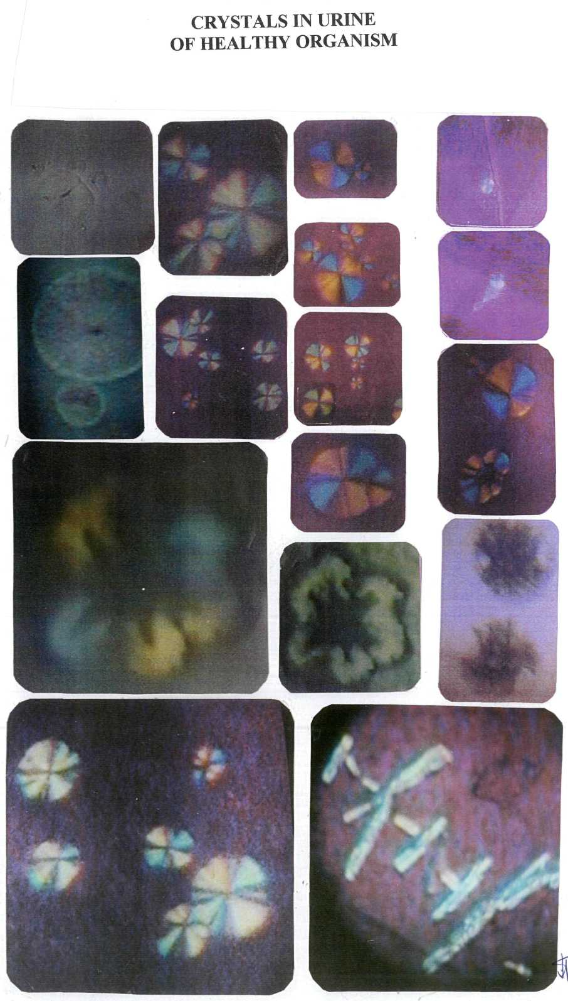
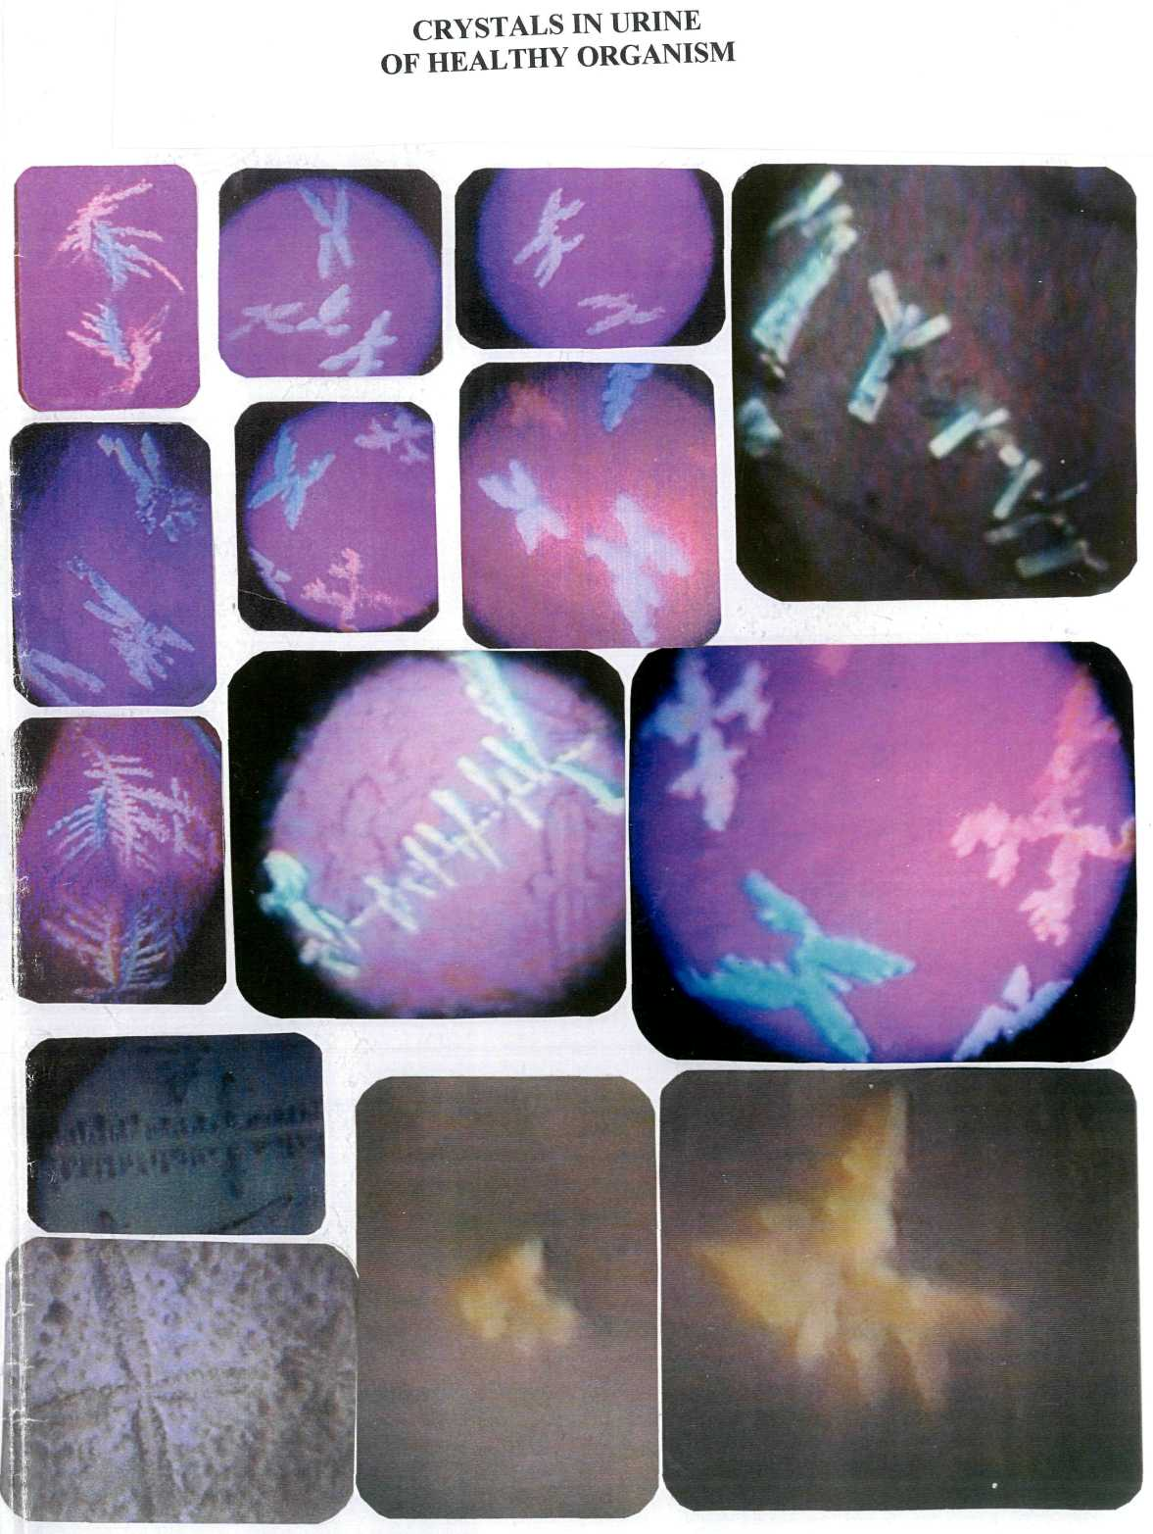
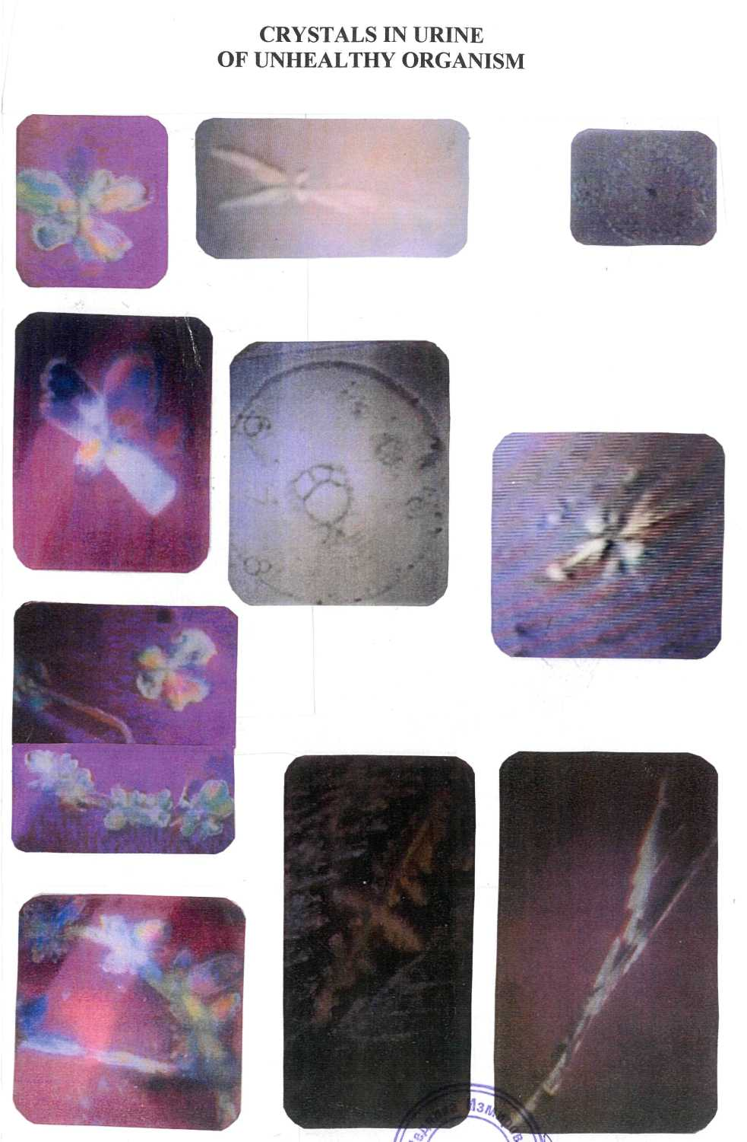
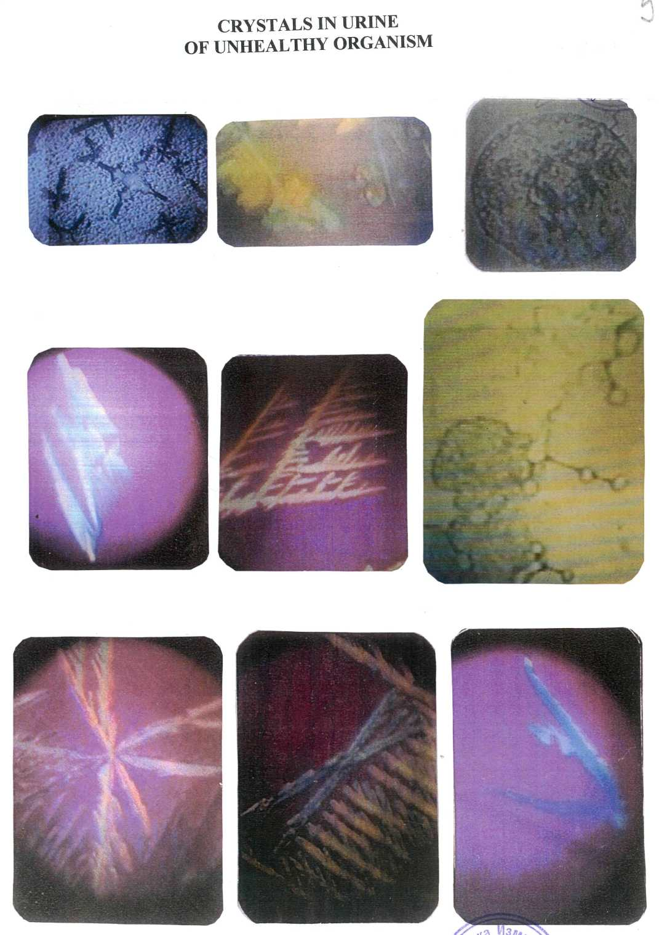

Hypothesis

The spherulite crystals in urine of healthy organism possess infinite symmetry. They are formed by a great number of symmetrically arranged bent lamellas covered with glyco- and lipoprotein in which information is set for quick reproduction of the complex structure of the spherulites.The lamellas form a symmetric inner aperture diameter of which is determined by fan-shaped opening and shutting of the lamellas. The next specific properties of the spherulites are observed:
1) They form two-dimensional layers, rise and quickly reproduce self-like complex crystal structures.
2) The polymorphism is a basic property of spherulites that leads to transformation of the spherulites to anisotropic crystals of dendrite and sceleton type.
3) The anisotropic crystals interact between themselves with conservation of the basic properties of the crystals.
The spherulites (observed in over saturated solution of urine -healthy organism) represent a mezomorphous state of the matter , so they hypothetically are liquid crystals.
The spherulites take part in the basic catalytic reactions in the organism. They ensure the most economical metabolisms, in the biochemical processes. Due to their molecular sieve and ion exchange properties, the spherulites take part in the detoxification of the ammonium, and the non-protein nitrogen substances. They ensure sodium potassium balance, and osmotic pressure balance. Being water-soluble, the spherulites can pass through the intestinal mucous, and in the presence of Cpt.z, can, under certain conditions, to interact with the mineral.
The spherulytes (observed in the urine of healthy organism) appear as basic structure for communication between the cells in the living matter.

Discussion

The performed comparative evaluation of diffraction patterns of Cpt extracted from the
rock in powder with Cpt.z in powder, established the present of minor quantities of
Crystobalite, Montmorillonite, and Feldspare as well.

For the purpose of investigation Cpt.z in powder was used instead of Cpt because
Crystobalite and Feldspare are inactive while Montmorillonite with its ion exchange,
absorptive, etc. properties, will help and even enhance the healing effect of Cpt.z.
The Bulgarian Cpt.z from NE Rhodopes has no general toxic effect upon liver, lung,
heart, spleen and kidneys of laboratory animals. Cpt.z has no clastogenic effect upon the
mice bone marrow [11].
Cpt.z has no carcinogenic effect on laboratory animals - mice and rats.The investigations of prof. Blagoeva [11] deny the assertion that Bulgarian Cpt.z. possesses carcinogenic activity [8].

As an ion-exchanger Cpt.z. serves for maintaining the osmotic pressure, regulation of
acid-based equilibrium, electrolytic and mineral balance in the organism.

The hardness of the Cpt.z. is between 3.5-4 and it has cleaning effect without abrasive
such and does not effect the enamel surface of the teeth. This cleaning effect leads to
preservation of the natural gloss of the enamel.
The Bulgarian natural Clinoptilolite rock (with Clinoptilolite up to 85-92%) in the region of NE Rhodopes Mountains could be used successfully in humanitarianр ьха эешеисхьисьх medicine and for prophylactic nutrition without any enrichment, purification, or modification.

Acnowledgments

Thanks are due to the Ministry of Education and Science for the financial support (Contract No 103/1998) and especially to the Deputy-Minister Prof. Christo Balarew as well as to Acad. Ivan Kostov for their help and critical remarks.

References
l.B. Aleksiev, - The Zeolite deposits in Bulgaria, Thesis, 1984. (Bulg.)
2.E.Djourova, Thesis, 1981. (Bulg.)
3.V.Marinov,. Thesis, 1985. (Bulg.)
4.I.Uzunov, "Problems connected with the estimation of the carcinogenic risks caused by hot particles" in Simposium on radiation studies and defeats, 16-18 Dec, 1987, Research reports, part III, National research program on radiation protection, p. 15-18. (Bulg.)
5.I.Uzunov, Harmful consequenses due to hot particles falling in the human organism and the necessary precautions, Reprt to BAS, 17.06.1986. (Bulg.)
6.Z.Bonchev, I.Mandjukov, B.Manushev, in the book Truth for Chernobyl contaminations in Bulgaria",Sofia University publishers "Kliment Ochridski" pp. 56-59, 1990. (Bulg.)
7.L.Filizova, The use of zeolites to counteract Chernobyl fallout, 4-th International conference in the occurrence, properties and utilization of natural zeolites, Boise, Idaho, June 20-28, 1993, pp. 88-90.
8.St.Nikolova,, Hygiene assessment of the Bulgarian zeolite rocks' dust. Dissertation, 1986, 118-125 (Bulg.).
9.M.Dobreva, et al. Validity of some short turn tests in pathogenicity study of mineral dusts. XIII Czechoslovak Symposium on Industrial Dust, Bratislava - Smolenice, May 18th-21st, 1987, pp. 136-144.
lO.N.Shumkov, K.Kolev, St.Nikolova, Blastomogenic activity of Bulgarian zeolites. XIII Czechoslovak Symposium on Industrial Dust, Bratislava- Smolenice, May 18th -21st, 1987, pp. 275-281 (Russ).

11 .P.Blagoeva, Z.Gendgev, N.Izmirova, and Tz.Mircheva, Investigation for
carcinogenesis of Clinoptilolite zeolitite ) on mice and rats, Report to the Ministry of
Science and Education, No.54919/20.12.2001, Sofia, Bulgaria.
12.N.Izmirova, P. Blagoeva, Z. Gendgev, Tz. Mircheva, B. Aleksiev, E. Djourova, L.
Minev, T.Bozhkova, D.Pressiyanov, P.Uzunov, I.Tomova, R. Bozhikova, M. Atanasov.
BG Patent No. 105298 (2001).

13.N.Izmirova, et al, The administration of natural Clinoptilolite for prophylactic
purposes, relief of ailments, and decrease of the risk of tumour formations, ICMAN, 1st
International Conference on Mechanisms of action of nutraceuticals, Cavtat, Dubrovnik,
Croatia, Oct. 14-19,2001, P-5.
14.N.Izmirova, B.Aleksiev, E.Djourova, M.Baeva, A.Boianova, P.Blagoeva, L.Minev,
T.Boshkova, D.Pressianov, P.Uzunov, I.Tomova, Tz.Mircheva, M.Bozhikov,
R.Bozhikova, Patent No. 106511 (2002).
15.N.Izmirova, Patent No. 106642 (2002).
16.N.Izmirova and B.Aleksiev, BG Patent No.104049 (1999).
17.N.Izmirova, Patent No. 104359 (2000).
18.N.Izmirova et al, Diagnosis, profilaxis and healing by clinoptilolite zeolitite, Zeolite

'02, 6-th International Conf, Occurance, properties and utilization of natural zeolites,
Thessaloniki, Greece, June 3-7, 2002, p. 150, Book of Abstracts, P.Misaelides (Editor).
19. Izmirova,N., L.Minev, T.Bozhkova, D.Pressiyanov, P.Uzunov, B.Aleksiev,
E.Djourova, I.Tomova, M.Baeva, A.Boyanova, Tz.Mircheva, P.Blagoeva, T.Todorov,
and R.Petrova, Oncology '99, VI National Congress on Oncology with International
Participation, Nov.19-20, Sofia (1999), 9-10 (Bulg.).

