NITROSATIVE/ OXIDATIVE STRESS - GU SPHERULITES IN BIOLOGICAL LIQUIDS AS AN INDICATOR AND NATURAL ZEOLITE TO REDUCE THE CONSEQUENCES OF STRESS

4
N. Izmirova^{1*}, P. Uzunov ², I. Tomova³, M. Baeva⁴

¹National Center of Hygiene and Occupational Health,Ministry of Health, ²Bulgarian Academy of Sciences, Institute of Solid State Physics, ³Sofia University “St. KlimentOhridski, Faculty of Physics, Laboratory of Dosimetry and Radiation protection,⁴ BodybactMicrobiologicalLaboratory – soleproprietor, Ltd. Sofia, Bulgaria

izmirovan@yahoo.com

ABSTRACT

Nitrosative and oxidative stress lead to biochemical changes in the metabolism of lecithin and cholesterol [3]. The LDL serum levels of Alzheimer's patients are credibly increasing [1].
In case of pesticide poisoning, the cholesterol level increases in both serum and urine. It circulates related to phospholipids. In a healthy person they build a spherical particle structure (spherulites). For the first time, such particles with liquid crystal properties have been observed in oversaturated solutions of biological fluids from urine, throat, sweat, bile and nasal secretions [2]. Spherulites have endless symmetry (Figures 1 and 2). They are spherical, spheroidal or disk-shaped. They grow radially radiant. A plurality of lamellas forms a centrally located pore. In in vitro conditions (in a buffered solution of ascorbic acid) the spherulites are dissolved (Figure 3), their lamellas are untwisted (Figure 4) and anisotropic crystals of letter-sign type (Fig 5) are formed as a result of polymorphic conversion. The crystalline phase of the spherulites is made up of guanidine-urea [guanidine-ureic spherulite (GU Sph)] skeleton - C6H18N12O3:

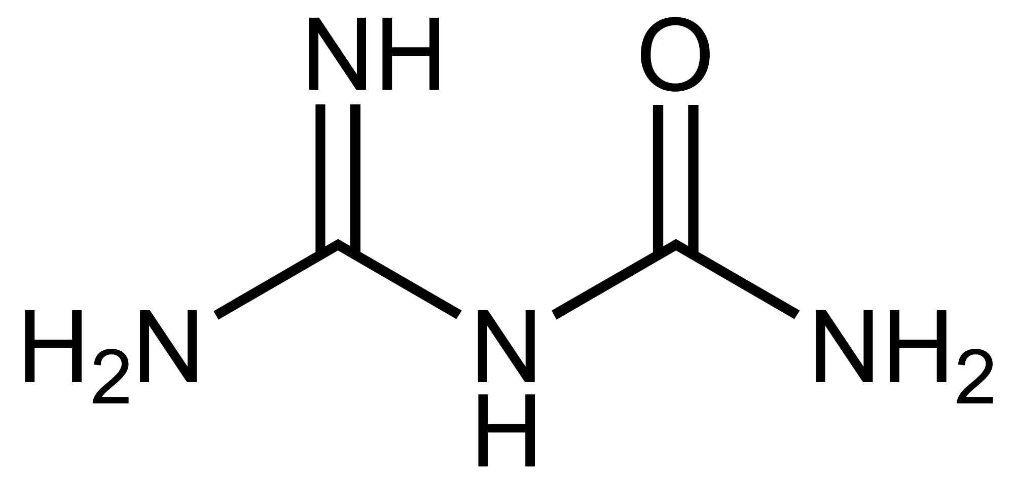 [C2H6N4O]3

Guanidinium urea (GU) is a metabolic productfromthedecomposition of purinebases. GUis a biologicallyactivecompound and isastartingbaseforthesynthesis of purine,adenine andguanine.
GU spherulites have catalytic, molecular sieve, adsorption and ion-exchange properties [2].
Natural zeolite is important for maintaining health. After oral administration under the hydrochloric acid (HCl) action in stomach, the zeolite is protonated. Released K⁺ and Na⁺ fall into the duodenum and, with increased acidity,they alkalize the medium and remove discomfort. K⁺ and Na⁺ bind to bile acids and convert them into colloid-soluble salts, which form micelles and improve digestion. The protonated, highly active zeolite purifies GU spherulites from NH4⁺, peroxinitrite (ONOO-) and other N-containing products from the metabolism.

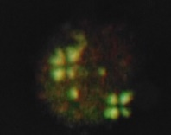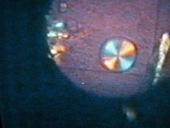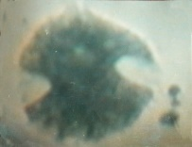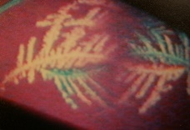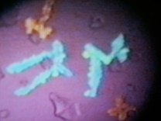

Fig.1 Fig.2 Fig.3 Fig.4 Fig.5

References:
1. Dildar, Konukoğlu MD*; Sinem, Firtina MD*; Gökhan, Erkol MD†; Orhan, Yağiz MD‡; Filiz, Manga MD‡
Serum Nitrosative Stress Levels Are Increased in Alzheimer Disease but Not in Vascular Dementia,Alzheimer Disease & Associated Disorders: April-June 2010 - Volume 24 - Issue 2 - p 194-197
2. N. Izmirova, P.Uzunov, I. Tomova, M. Baeva
Spherulites in Biological Fluids, Antioxidants and Natural Zeolites – Phenomenon and Utilization, p 177, 7th FEZA CONFERENCE, The ZEOLITES: Materials with Engineered Properties, Book of Abstracts, July 3-7, 2017, Sofia, Bulgaria, p.324.
3. N. Izmirova, P. Uzunov, I. Tomova, M. Baeva
Cholesterol and Spherulites as a Lyotropic Crystal Liquid State of Matter, Pharmaceutical Monitor, 2014, 6(81), PP 15-20.

