Spherulites in Biological Fluids, Antioxidants and the Natural Zeolite - Phenomenon and Utilization

N. Izmirova, B - P. Uzunov, C - I. Tomova, D - M. Baeva
1/1/2016

A - “Clinalex – Nedyalka Izmirova” Ltd., Bulgaria, 1000 Sofia, 27 Pirotska Str., izmirovan@yahoo.com; B - Sofia University “St. Kliment Ohridski”, Department of Physics; C - Bodybact Microbiological Laboratory – sole proprietor, Ltd. 1000 Sofia; D - Institute of Solid State Physics to the Bulgarian Academy of Sciences, Sofia, Bulgaria

This paper summarizes our observations and studies on spherical particles - spherulites in biological fluids.
Spherulites exist in highly concentrated biological fluids such as urine, guttural, sweaty or bile secretion. Their form is similar to a disc, spherical or spheroidal and crystal particles. Lamellae, radially arranged in a structure, form a centrally situated tubular opening (a pore). The diameter of spherulites ranges from 25 μm up to 150 μm. They contain hydrophilic and hydrophobic, fibrillar lipoproteins. The cholesterol and the lecithin are the main substances, that make up their complex structure. The crystal phase therein is a derivative of the amidinourea (H18C6N12O3) [2, 3]. In healthy people they are almost of infinite symmetry [4]. When intoxications are observed, the spherulites become densified and their symmetry is violated. Under stress conditions the reductive capacity of the organism is exhausted. When water-soluble antioxidant (ascorbic acid - vitamin C) is perorally introduced, it rapidly recovers the reduction-oxidation potential of the body. It was found that the introduction of Vitamin C results to an increased number of spherulites in the urine.
Spherulites are found in highly concentrated aqueous solutions of ascorbic acid and in other substances of antioxidant properties.
The stress disorder in the body results to increased levels of NH₄⁺ in the circulating blood (NH₄⁺ is very toxic to the central nervous system). The availability of natural zeolite (with > 85% clinoptilolite) in the lumen of the gut, after peroral introduction of the mineral, adsorbs NH₄⁺, enhances the digestion and removes the discomfort in the gastrointestinal tract in case of elevated gastric acidity.
Methods and materials
Spherulites have specific anisotropic optical properties, which can be observed by the method of the polarization microscopy [1].
A fresh urine sample of 0,1 ml is applied to a leveling microscope slide and allowed to evaporate at ambient temperature for obtaining a highly concentrated solution. The sample is reported under crossed Nicols, compensated at magnification of ×40, or x60. The observation is photographed with a video camera.
When determining the needs and the saturation limits of the body with vitamin C, a single dose of 500 mg is accepted thereof. The degree of saturation [9] is defined by the amount of the antioxidant that is emitted in the urine after dosing (in 4-5 hrs).

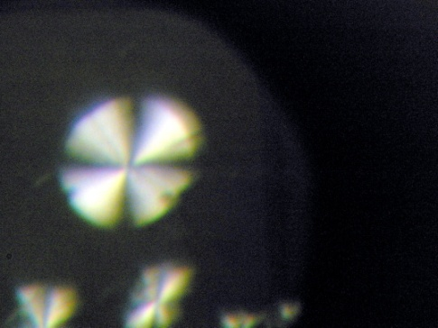
Results and Discussion

By microscopic observation with crossed Nicols, spherulites acquire cross-like darkening, which is typical of them (Figures 1, 1-1, 1-2, and 1-3).
Figure 1
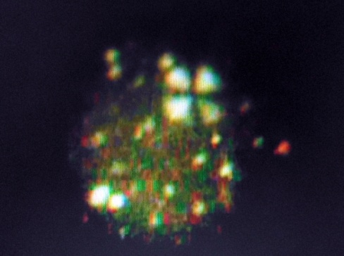
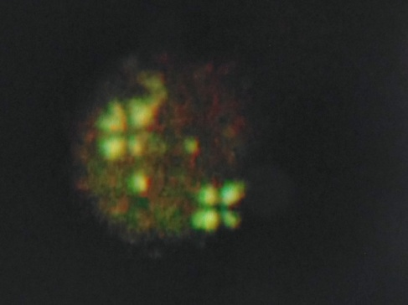
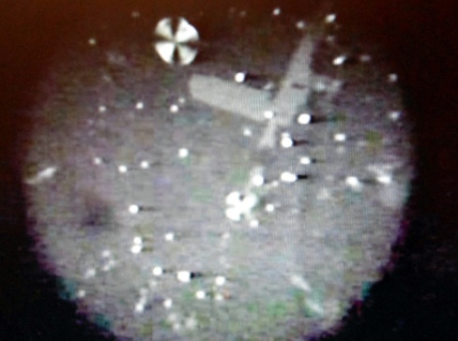
Fig. 1-3
Fig. 1-2
Fig. 1-1

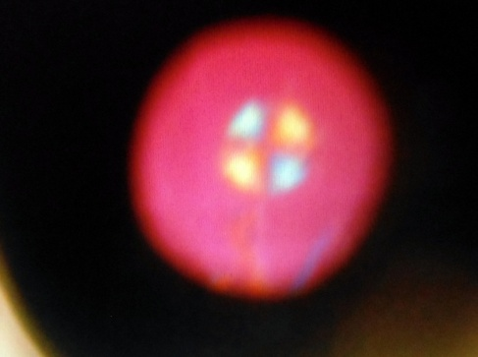
Spherulites grow radially and they are reproduced (Figs. 2, 2-1, 2-2, 2-3, and 2-4). They have a curvilinear (not crystallographic) symmetry, which depends both on the specific properties of the crystal phase and on the conditions, under which they are growing [4].
Fig. 1
Fig. 1-1 Fig. 1-2
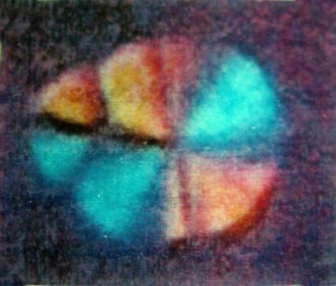
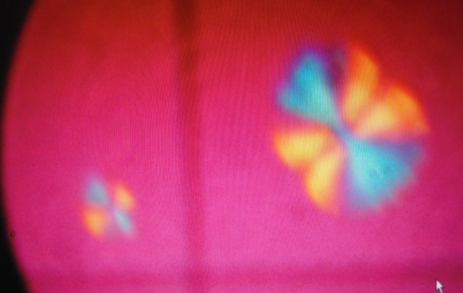
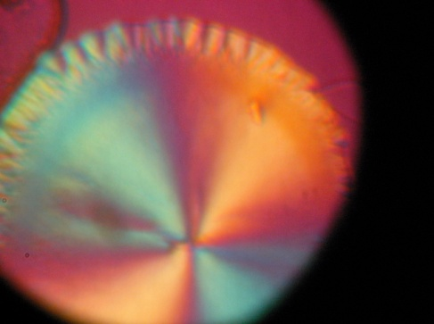
Fig. 2-1 Fig. 2-2 Fig. 2-3
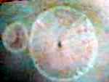
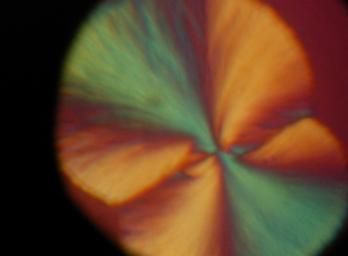
Spherulites in healthy humans have almost infinite symmetry, a loose structure and a well-formed, centrally located pore (Fig. 2-5).
Fig. 2-4 Fig. 2-5
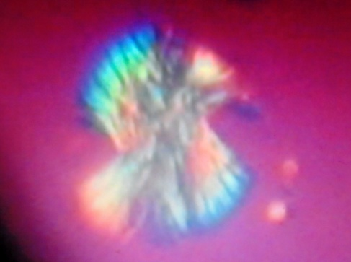
In the event of in-vitro, after adding a buffered solution of ascorbic acid to a urine sample (containing a number of spherulites), a process of dissolution of the spherulites was observed, their lamellae were disentangled (Figs. 3, 3-1, 3-2, and 3-3), and they themselves were converted into self-aligning crystalloids (Figs. 4, 4-1, 4-2 and 4-3), also in the form of letter type anisotropic crystalloids (Figs. 5, 5-1, 5-2, and 5-3), and decomposing into isotropic, water soluble cross-like crystalloids. (Fig. 6).
Fig. 3
Fig. 3

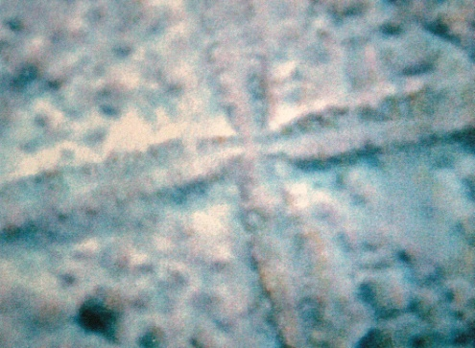
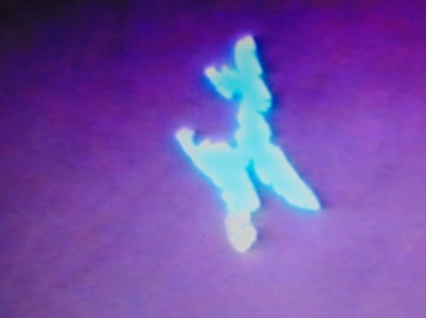
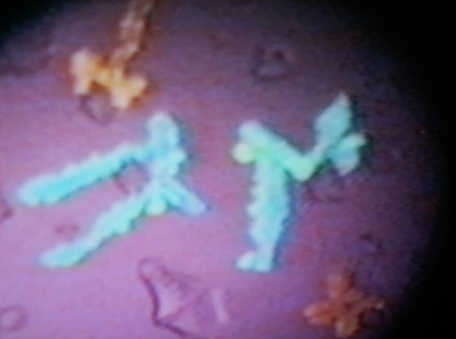
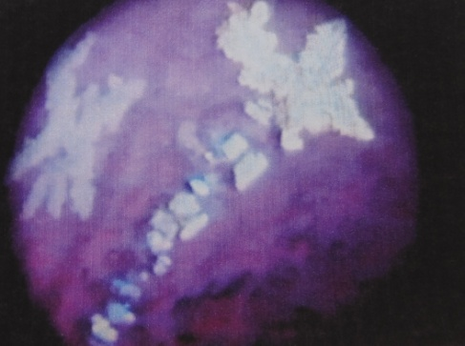
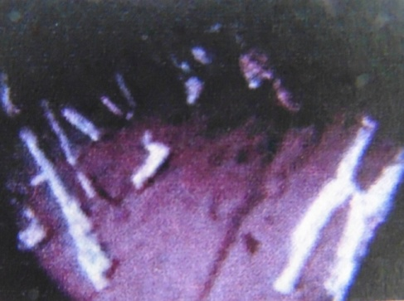
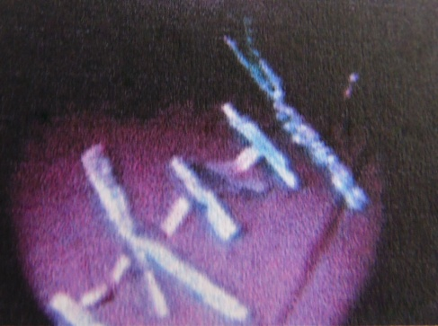
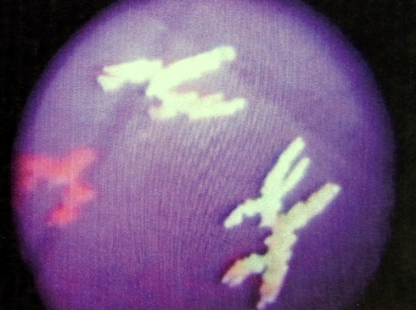
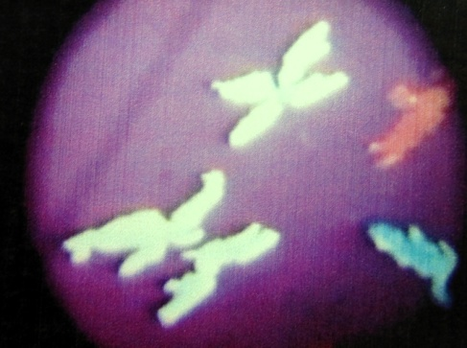
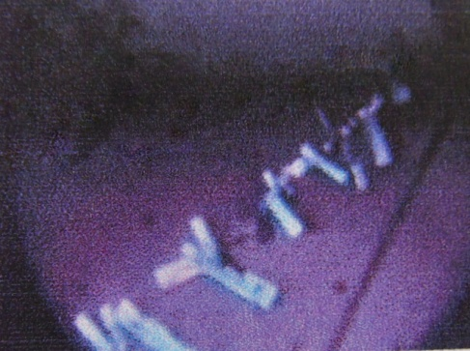
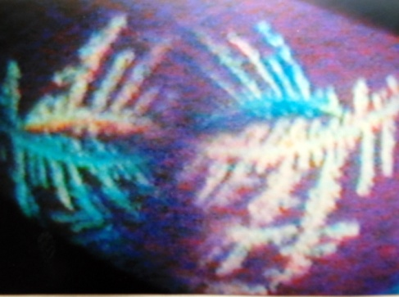
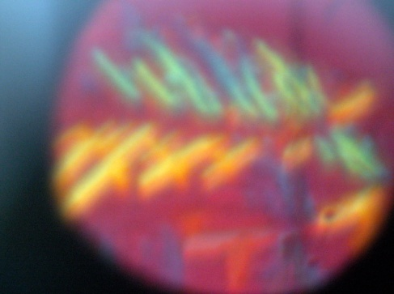
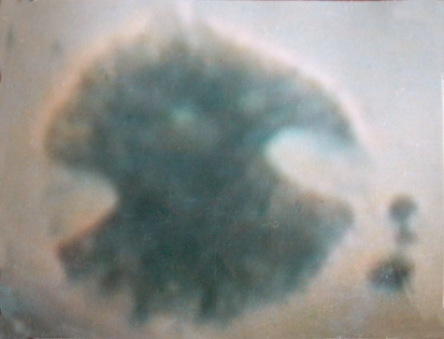
Fig. 5-2 Fig. 5-3 Fig. 6
Fig. 4 Fig. 4-1 Fig. 4-2
Fig. 4-3 Fig. 5 Fig. 5-1
Fig. 3-1 Fig. 3-2 Fig. 3-3

Spherulites are biologically active micelles. In saturated solutions of biological fluids (urine, guttural, nasal, sweat and bile secretions) they demonstrate properties, typical of the lyotropic liquid crystal state of the matter [5, 6].
The availability of single spherulites and single crystalloids in the form of letter type and a number of isotropic crystalloids, with parallel fins in saturated solutions of the urine, is an indicator of good health.
Fig. 6
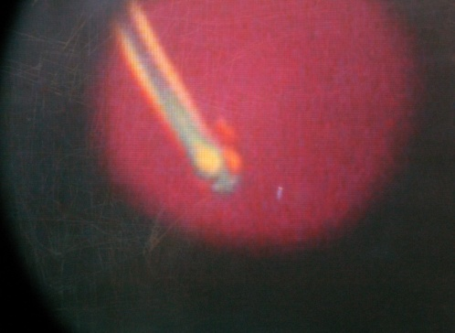
Under stress conditions and intoxications spherulites undergo a change. In Fig. 7 part of the spherulite has a tubular extension (a sample of nasal discharge - a nasal polyp). When enriched in cholesterol, spherulites undergo a structural transition - from spherulites of a curvilinear symmetry to ones of planar, crystallographic symmetry (Figs. 7-1, 7-2, 7-3).
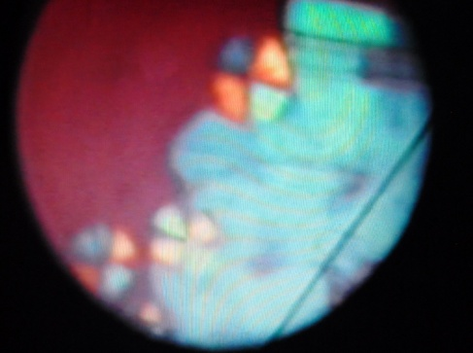
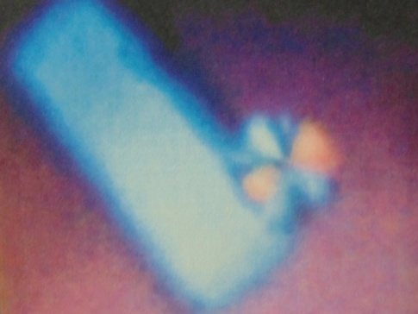
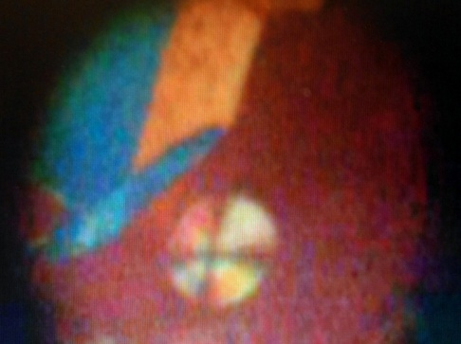
Fig. 7
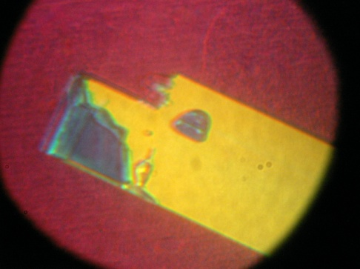
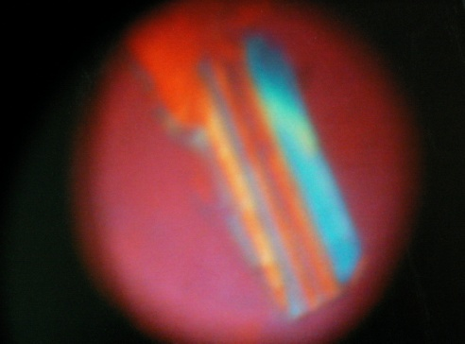
Fig. 7-1 Fig. 7-2 Fig. 7-3
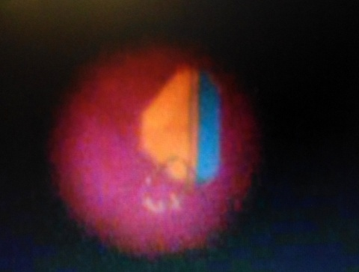
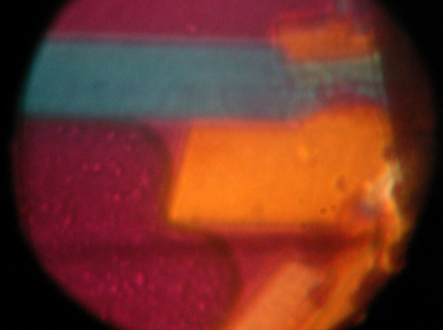
The cholesterol in the spherulites, being in liquid crystal state, passes transition into solid cholesterol crystals (Figs. 7-4, 7-5, 7-6 and 7-7). The risk of formation and deposition of cholesterol plaques in blood vessels is increased [6].
Fig. 7-4 Fig. 7-5
The availability of spherulites (in oversaturated solutions of urine) with concentric growth, or of deformed, agglutinated, or encapsulated spherulites, is an indication of disease state of an organism.
Fig. 7-6 Fig. 7-7
In addition to biological fluids, spherulites were observed in highly concentrated aqueous solutions of acetyl-thio-choline – a strong antioxidant involved in the synthesis of acetylcholine, one of the main mediators of nerve impulses (Figs. 2-6 and 2-7).
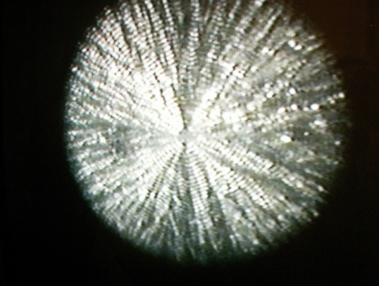
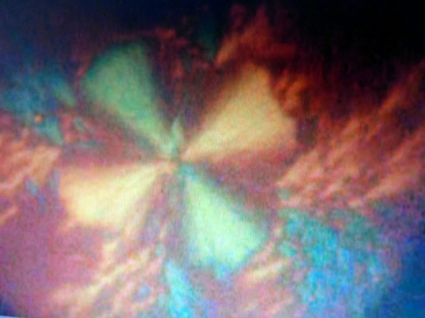

Fig. 2-6 Fig. 2-7
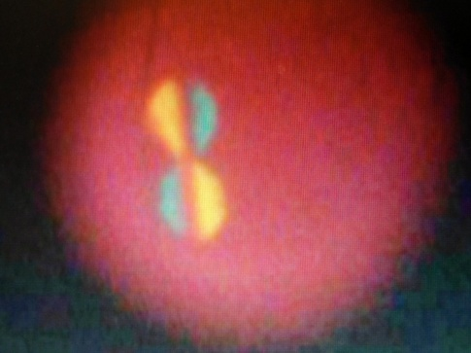
At fermentation of water homogenates of blueberry and blackberry, cylindrically elongated, self-aligning, and reproducing spherulites were observed (Figs. 8, 8-1, 8-2, 8-3, 8-4, 8-5, 8-6, 8-6a and 8-7). There exists a trend to a structural transition from curvilinear to planar symmetry.
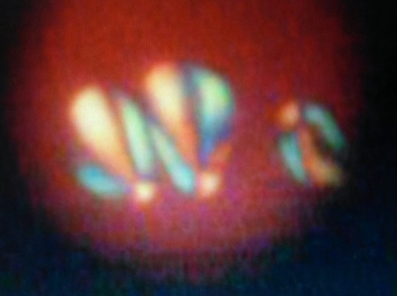
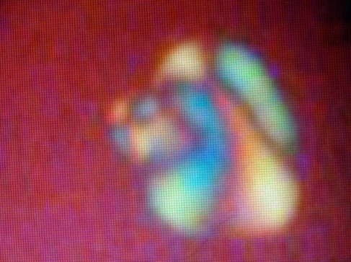
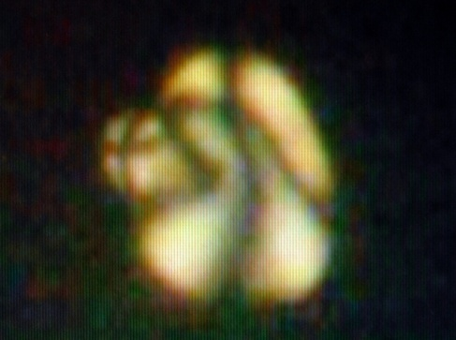
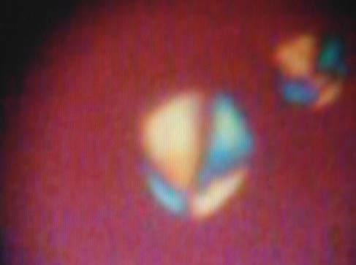
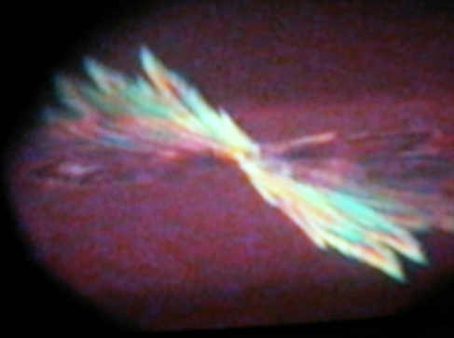
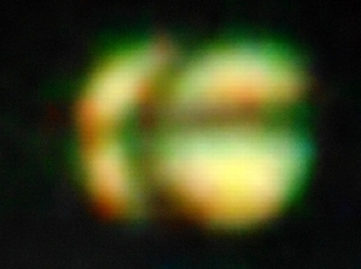
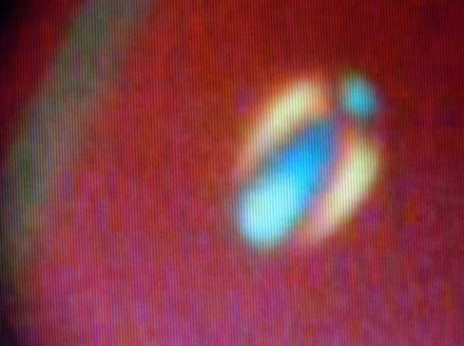
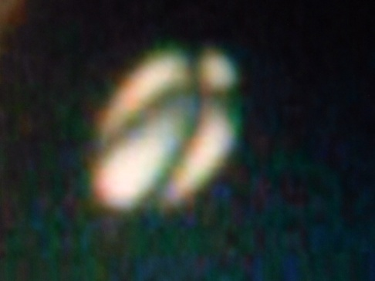
Fig. 8-6 Fig. 8-6a Fig. 8-7
Fig. 8-3 Fig. 8-4 Fig. 8-5
Fig. 8 Fig. 8-1 Fig. 8-2
We assume that the spherulites, observed in highly concentrated aqueous solutions (during the fermentation of blueberry and blackberry), are obtained as a result of activating the self-aligning structures of the anthocyanins.
Spherulites were observed also in buffered aqueous solutions with a high concentration of ascorbic acid (Vit. C) (Figs. 2-6 and 2-7). It was found that the saturation of the organism with Vit. C contributes to the increase in the urine of well formed spherulites with a pronounced curvilinear symmetry.
Everyone has a certain reduction capacity, that defines the biopotential of the body. For important biochemical systems this potential is within the range of +0.820 Е⁰ to -0.670 Е⁰ volt [8]. When the body redox balance is violated, the introduction of water-soluble antioxidant - vitamin C contributes to the restoration of this balance.
Under stress conditions, the redox potential of the red blood cells is quickly exhausted. Its recovery can be attained by saturating the body with vitamin C.
The reduction oxidation (redox) potential of ascorbic/dehydroascorbic acid is +0.08 Е⁰ volt). If two or more redox systems, of different redox potentials, are in contact, a transition of electrons from the system with a lower redox potential to the system with the higher one occurs.
The redox pair of ascorbic/dehydroascorbic acid (+0.08 E⁰ volt) plays the role both as a donor and as an acceptor of electrons. That is, by saturating the body with vitamin C, the latter appears as an oxidant in respect of systems with a lower redox potential of +0.08 E⁰ volt (such as Acetyl-Co A with -E⁰ 0.238 E⁰ volt and H₂- 2 H⁺with -0,420 E⁰ volt) and as a strong reducer in respect of redox systems higher than +0.08 E⁰ volt redox potential (such as NH₄ OH - hydroxylamine by +0.562 E⁰ volt and ½ O²- O²⁻ with +0.820 E⁰ volt) [8].
The deficiency of vitamin C greatly affects the metabolizing tissues, leading to a disruption of the digestive and nervous systems, damage of the skin and the blood cells. Any organism has individual needs of vitamin C, depending on a number of factors. They increase under stress conditions, intoxications, physical and mental stress.
Our observations indicate that by saturating with Vitamin C the spherulites, released in the urine, are of clearly expressed curvilinear symmetry. Vitamin C contributes for maintaining the normal flow of donor-acceptor biochemical reactions in the human body.

Clinoptilolite - natural phenomenon
A clinoptilolite is a mineral belonging to the group of natural zeolites. Natural zeolites (NZ) are widespread in the North-Eastern Rhodopes. In some NZ deposits the clinoptilolite content reaches up to 92%.
There are a number of natural landmarks in the area of the zeolite deposits (Fig. 9 - map of the natural zeolite deposits, published with the kind assistance of prof. B. Alexiev) [7]. The spherulites located on a rock of zeolite mushrooms can be seen on Figs. 9-1 and 9-2 (the Rock Hill near the village of Kostino). Andesite concentric tubes and tubular formations can be seen in Fig. 9- 4 (Asha Kazan- near the village of Djanka, Krumovgrad region).
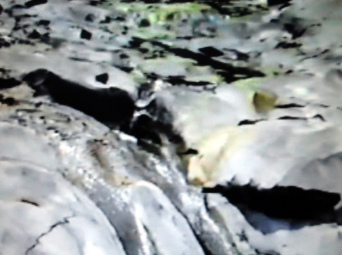
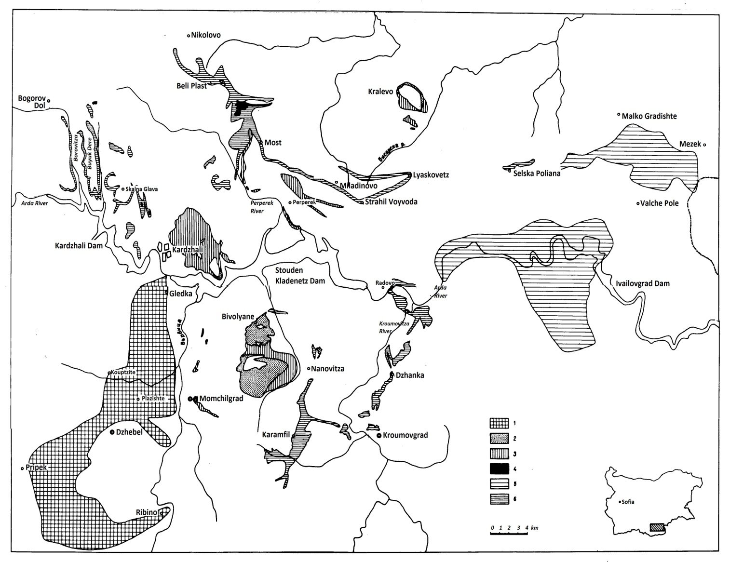
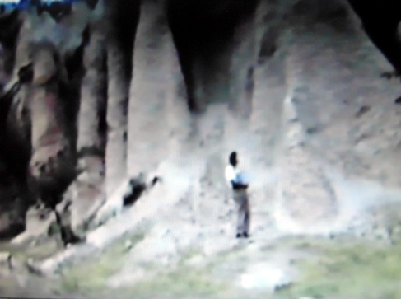
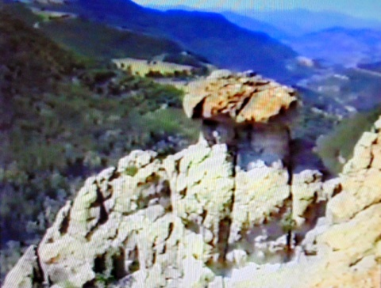
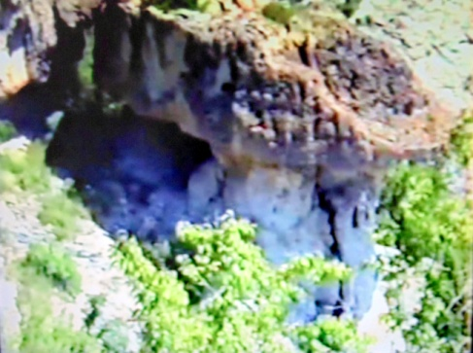
Fig. 9-1 Fig. 9-2 Fig. 9-3
Fig. 9

Fig. 9-4
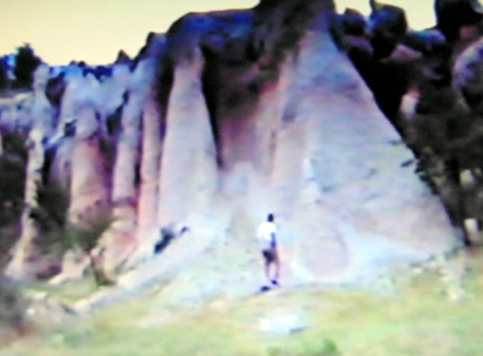
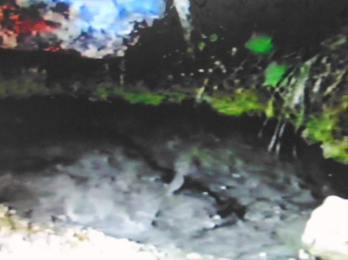
Near the zeolite rocks a mist is visible, shaped like semicircles and curvilinear symmetric conus (Figs. 9-3 and 9-5) - the Petrified Wedding landmark, near the village of Zimzelen).
Fig. 9-5 Fig. 9-6

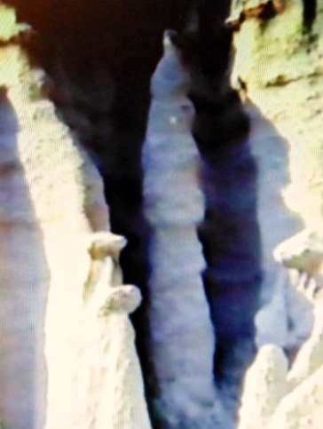
In Fig. 9-6 a circle of mist is spread above the water surface of a small well, whose bottom consists of rhyolite rock, resembling a coiled tube (the Petrified Forest, near the village of Nanovitsa, Momchilgrad region). From the blue surface of a towering slender and hollow rock figure a reflected white light flashes like two dots (Fig. 10 - the Monks landmark near the village of Priseltsi, Krumovgrad region (photos made by N. Izmirova).

Fig. 10
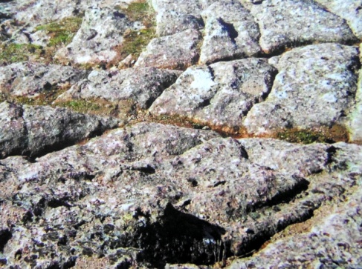
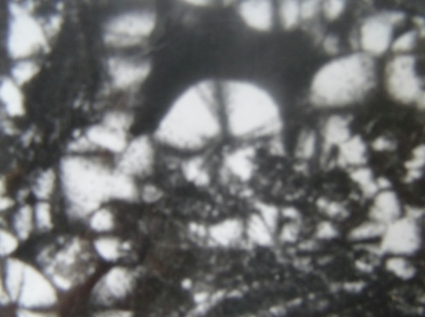
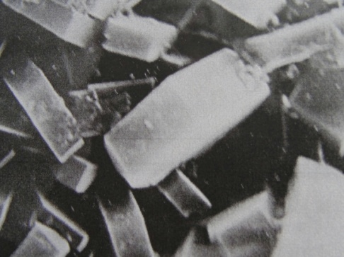
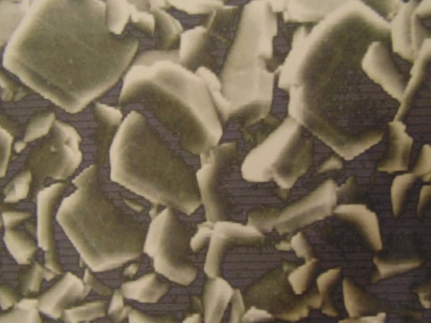
The majority of the landmarks are typical with their high content of the mineral clinoptilolite. The clinoptilolite is of fine grain crystal structure with well-formed platy habitus and typical monoclinic planar, crystallographic symmetry (Figs. 12 and 12 a). However, there are electronic microscopic images of NZ samples (a rock sample was taken at the border between clinoptilolite and mordenite deposit near the village of Lyaskovetz), where small granular spherical crystal aggregates(spherulites) can be seen of strong curvilinear (not crystallographic) symmetry (Fig. 11- ectronic microscope image published with the kind assistance of prof. B. Aleksiev) [7]. Concentric rock formations, resembling a part of a large spherolite, are visible in the natural landmark at the foot of Dambalaka volcano, near the village of Bivolyane, Momchilgrad region (Fig. 9-7).
Fig. 11 Fig. 12 Fig. 12a
Fig. 9-7
Fig. 9-7
It is possible, while the natural zeolites in the northeastern Rhodopes were being formed during the intense activity of Dambalaka volcano and the hydrothermal processes (more than 40 million years ago), with the transition of the molten andesite-rhyolite rock mass into solid rock, conditions for structural transition to have arisen. Fine-grained crystal aggregates (spherulites) of a curvilinear symmetry (Fig. 11) converted into small granular crystals of planar, crystallographic symmetry (Figs . 12 and 12 a).
The structure of the clinoptilolite (Cpt) comprises a plurality of pores of curvilinear symmetry. Water molecules and ions of alkali (K⁺, Na⁺) and alkaline earth elements (Ca⁺⁺ and Mg⁺⁺) circulate freely in them. This structure of the mineral determines its unique properties.
Being a mineral of the group of natural zeolites (which are of volcanic origin), the Cpt has a natural radioactivity. The natural radioactivity of the zeolite rocks in the area of the deposits (in Bq/kg) is as follows: ²³⁸U-50-185; ²²⁶Ra - 60-200; ²³²Th -120-170; ⁴⁰K - 750-1300. The measured power of exposure is between 35-40 μR/h.
Despite the increased levels of radionuclides to the main background radiation, the content of ²²⁶Ra in drinking water, passing through the zeolite rocks, is lower than the minimum provable activity - 0,07 Bq/1. With the exception of ⁴⁰K, the NZ does not release radioactive elements in the environment. The measured results, performed with tracking detectors for six months in the bedrooms of houses, built of zeolite stones, indicate that the radon in these areas does not exceed the background levels. Compared to other regions of this country, low oncological incidents rate was registered in regions with zeolite rocks [2].

Utilisation of clinoptilolite
Cpt has strongly manifested adsorption, catalytic, ion-exchange and molecular sieve properties. The clinoptilolite irreversibly adsorbs NH₄⁺, the latter being one of the metabolic breakdown products of the protein and purine metabolism. Increased levels of NH₄⁺ in the blood circulation is very toxic to the central nervous system.
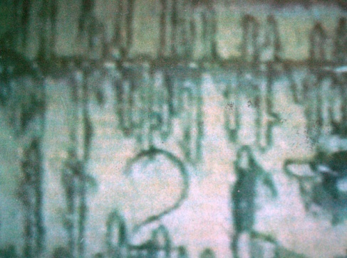
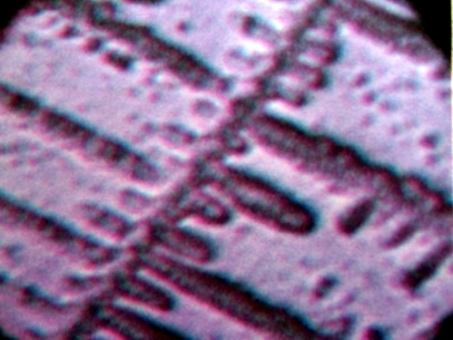
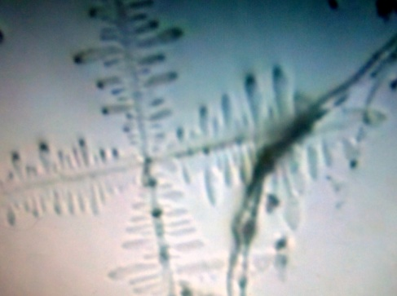
The peroral intake of natural Cp combined with a proportioned saturation of the organism with ascorbic acid enhances the polymorphic transformation of colloid soluble Sph into letter-type anisotropic crystals. The water soluble isotropic crystals (Figs. 6-1, 6-2 and 6-3), resulting from the hydrolytic breakdown of the spherulites, are excreted with urine.
Fig. 6-1 Fig. 6-2 Fig. 6-3

The potassium (K⁺) and sodium (Na⁺) ions released by Cpt enter the duodenum and help the regular process of transformation of the insoluble bile acids into colloid soluble mycelia of potassium and sodium salts, which improves digestion and accelerates detoxification processes.
The clinoptilolite is of mineral origin, but it is a biologically active substance with properties supporting digestion and digestive processes, and it contributes for maintaining a normal (healthy) weight. After peroral intake, its biological activity is revealed in the gastrointestinal tract, where it takes part in several important biological processes, it reduces the aggressiveness of the hydrochloric acid in case of increased gastric acidity. Cpt has rapid beneficial effect on diarrhea, pain, swelling and heaviness in the gastrointestinal tract.
The clinoptilolite is used as a dietary supplement for maintaining good health [5]. The ascorbic acid added to Cpt, enhances the function of cells and protects cell membranes from oxidative stress.

Literature:

- A. Petrov, The Lyotropic State of Matter: Molecular Physics and Living Matter Physics, Gordon and Breach Science Publishers, 89, 420, 443 pp.;
- N. Izmirova., B. Aleksiev, E. Djourova, P. Blagoeva, Z. Gendgev, Zt. Mircheva, D. Pressiyanov, L. Minev, T. Boshkova, P. Uzunov, I. Tomova, M. Baeva, A. Boyanova, T. Todorov and R. Petrova, Clinoptilolite and the Possibilities for its Utilization in Medicine, Stud. Surf. Sci. and Catalysis, 135, 2001;
- N. Izmirova, E. Djourova, B. Aleksiev, M. Baeva, P. Blagoeva, P. Uzunov, I. Tomova, A. Boyanova and Tz. Mircheva, Utilization of Natural Clinoptilolite for Reducing the Risk of Gall Stones and Renal Calculus, Second International Symposium, Advanced Micro- and Mesoporous Materials, Varna, Bulgaria, 6th-9th September, 2nd Humboldt Conference, Book of Abstracts, 186, 2007;
- R. I. Kostov, I. Kostov, Infinite Symmetry Applied to Crystals and Crystal Aggregates, Cryst. Res. Technol. 1989 24, 9, 847 – 852,
- N. Izmirova, P. Uzunov, I. Tomova, M. Baeva; Spherolites in Urine as an Indicator for Support of the Health, ACIN 2015 – New Era of Nanotechnology, Namur Belgium, 13th -17th July 2015, P-089;
- N. Izmirova, P. Uzunov, I. Tomova, M. Baeva, Cholesterol and Spherulites as a Lyotropic Crystal Liquid State of Matter, Pharmaceutical Monitor, 2014, 6(81), PP 15-20;
- B. Aleksiev, Natural Zeolites – the New Raw Material of Bulgaria, Dissertation, 1984;
- Martin David W. et all- Harper’s Review of Biochemistry, 19th Edition, Lange Med. CAL Publ. Los Altos, California, USA, 1983, p. 112- 128.
- N. Izmirova, Method for determination the needs and limits of saturation of the body with Vitamin C, by defining vitamin C in the urine, Patent № 104878/2000.

A lyotropic liquid crystal state of the matter occurs, when organic crystal solid (lipids, proteins, etc.) are dissolved in water or other polar (and non-polar) fluids, and when the concentration of the solution is high enough [1].
The natural radioactivity of zeolite rocks was measured in the Laboratory of Dosimetry and Radiation Protection, Department of Atomic Physics at Sofia University "St. Kliment of Ohrid".

